**Project Design Phase-II**

**Technology Stack (Architecture & Stack)**

|  |  |
| --- | --- |
| Date | 27 October 2022 |
| Team ID | PNT2022TMID15069 |
| Project Name | Personal Assistance for Seniors Who Are Self-Reliant |
| Maximum Marks | 4 Marks |

**Technical Architecture:**

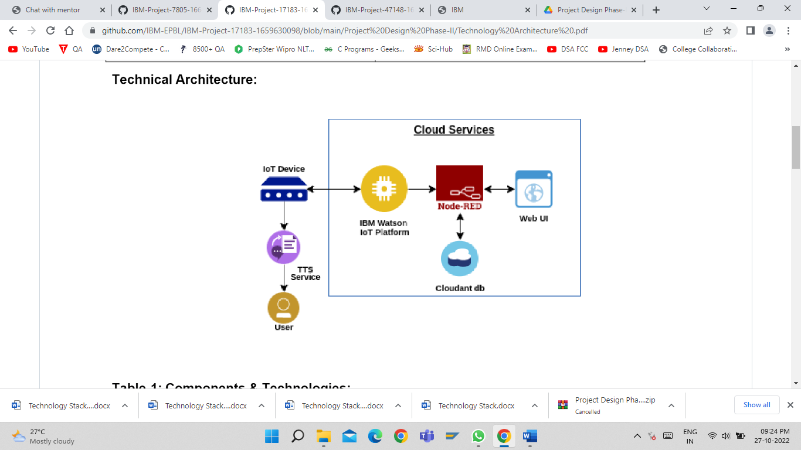

**Table-1: Components & Technologies:**

|  |  |  |  |
| --- | --- | --- | --- |
| **S. No** | **Component** | **Description** | **Technology** |
|  | User Interface | Mobile App | HTML, CSS, Angular Js |
|  | Application Logic-1 | When the medicine time arrives, the web application will send an alarm | Python |
|  | Application Logic-2 | Gets the medication data from database | IBM Watson |
|  | Application Logic-3 | Notify the user with voice command | IBM Watson Assistant |
|  | Database | Medication time and tablets name on daily basis | MySQL |
|  | Cloud Database | Database Service on Cloud | IBM Cloudant |
|  | File Storage | App code and IoT credentials are stored and API keys | IBM Block Storage |
|  | External API-1 | To get the medicine box status | IBM Box Status API |
|  | Machine Learning Model | To convert the text into speech for voice command the tablet details | Text to Speech |
|  | Infrastructure (Server / Cloud) | To host server and application | Cloud Foundry, Node Red. |

**Table-2: Application Characteristics:**

| **S.No** | **Characteristics** | **Description** | **Technology** |
| --- | --- | --- | --- |
|  | Open-Source Frameworks | Mobile Application Development, programming IoT, Text to Speech conversion, data storage in cloud | IBM Watson, Node Red, IBM Cloudant |
|  | Security Implementations | Implementation of encryption | SHA-256 |
|  | Scalable Architecture | Multiple user login allowed | MIT, IBM Watson |
| 4. | Availability | 2/7 availability of application | MIT, IBM Watson, Node Red, IBM Cloud |
| 5. | Performance | Accuracy in remainders with alarms | IBM Watson, IBM IoT Platform |